(Address of submitting the request:

info@hpm.hr

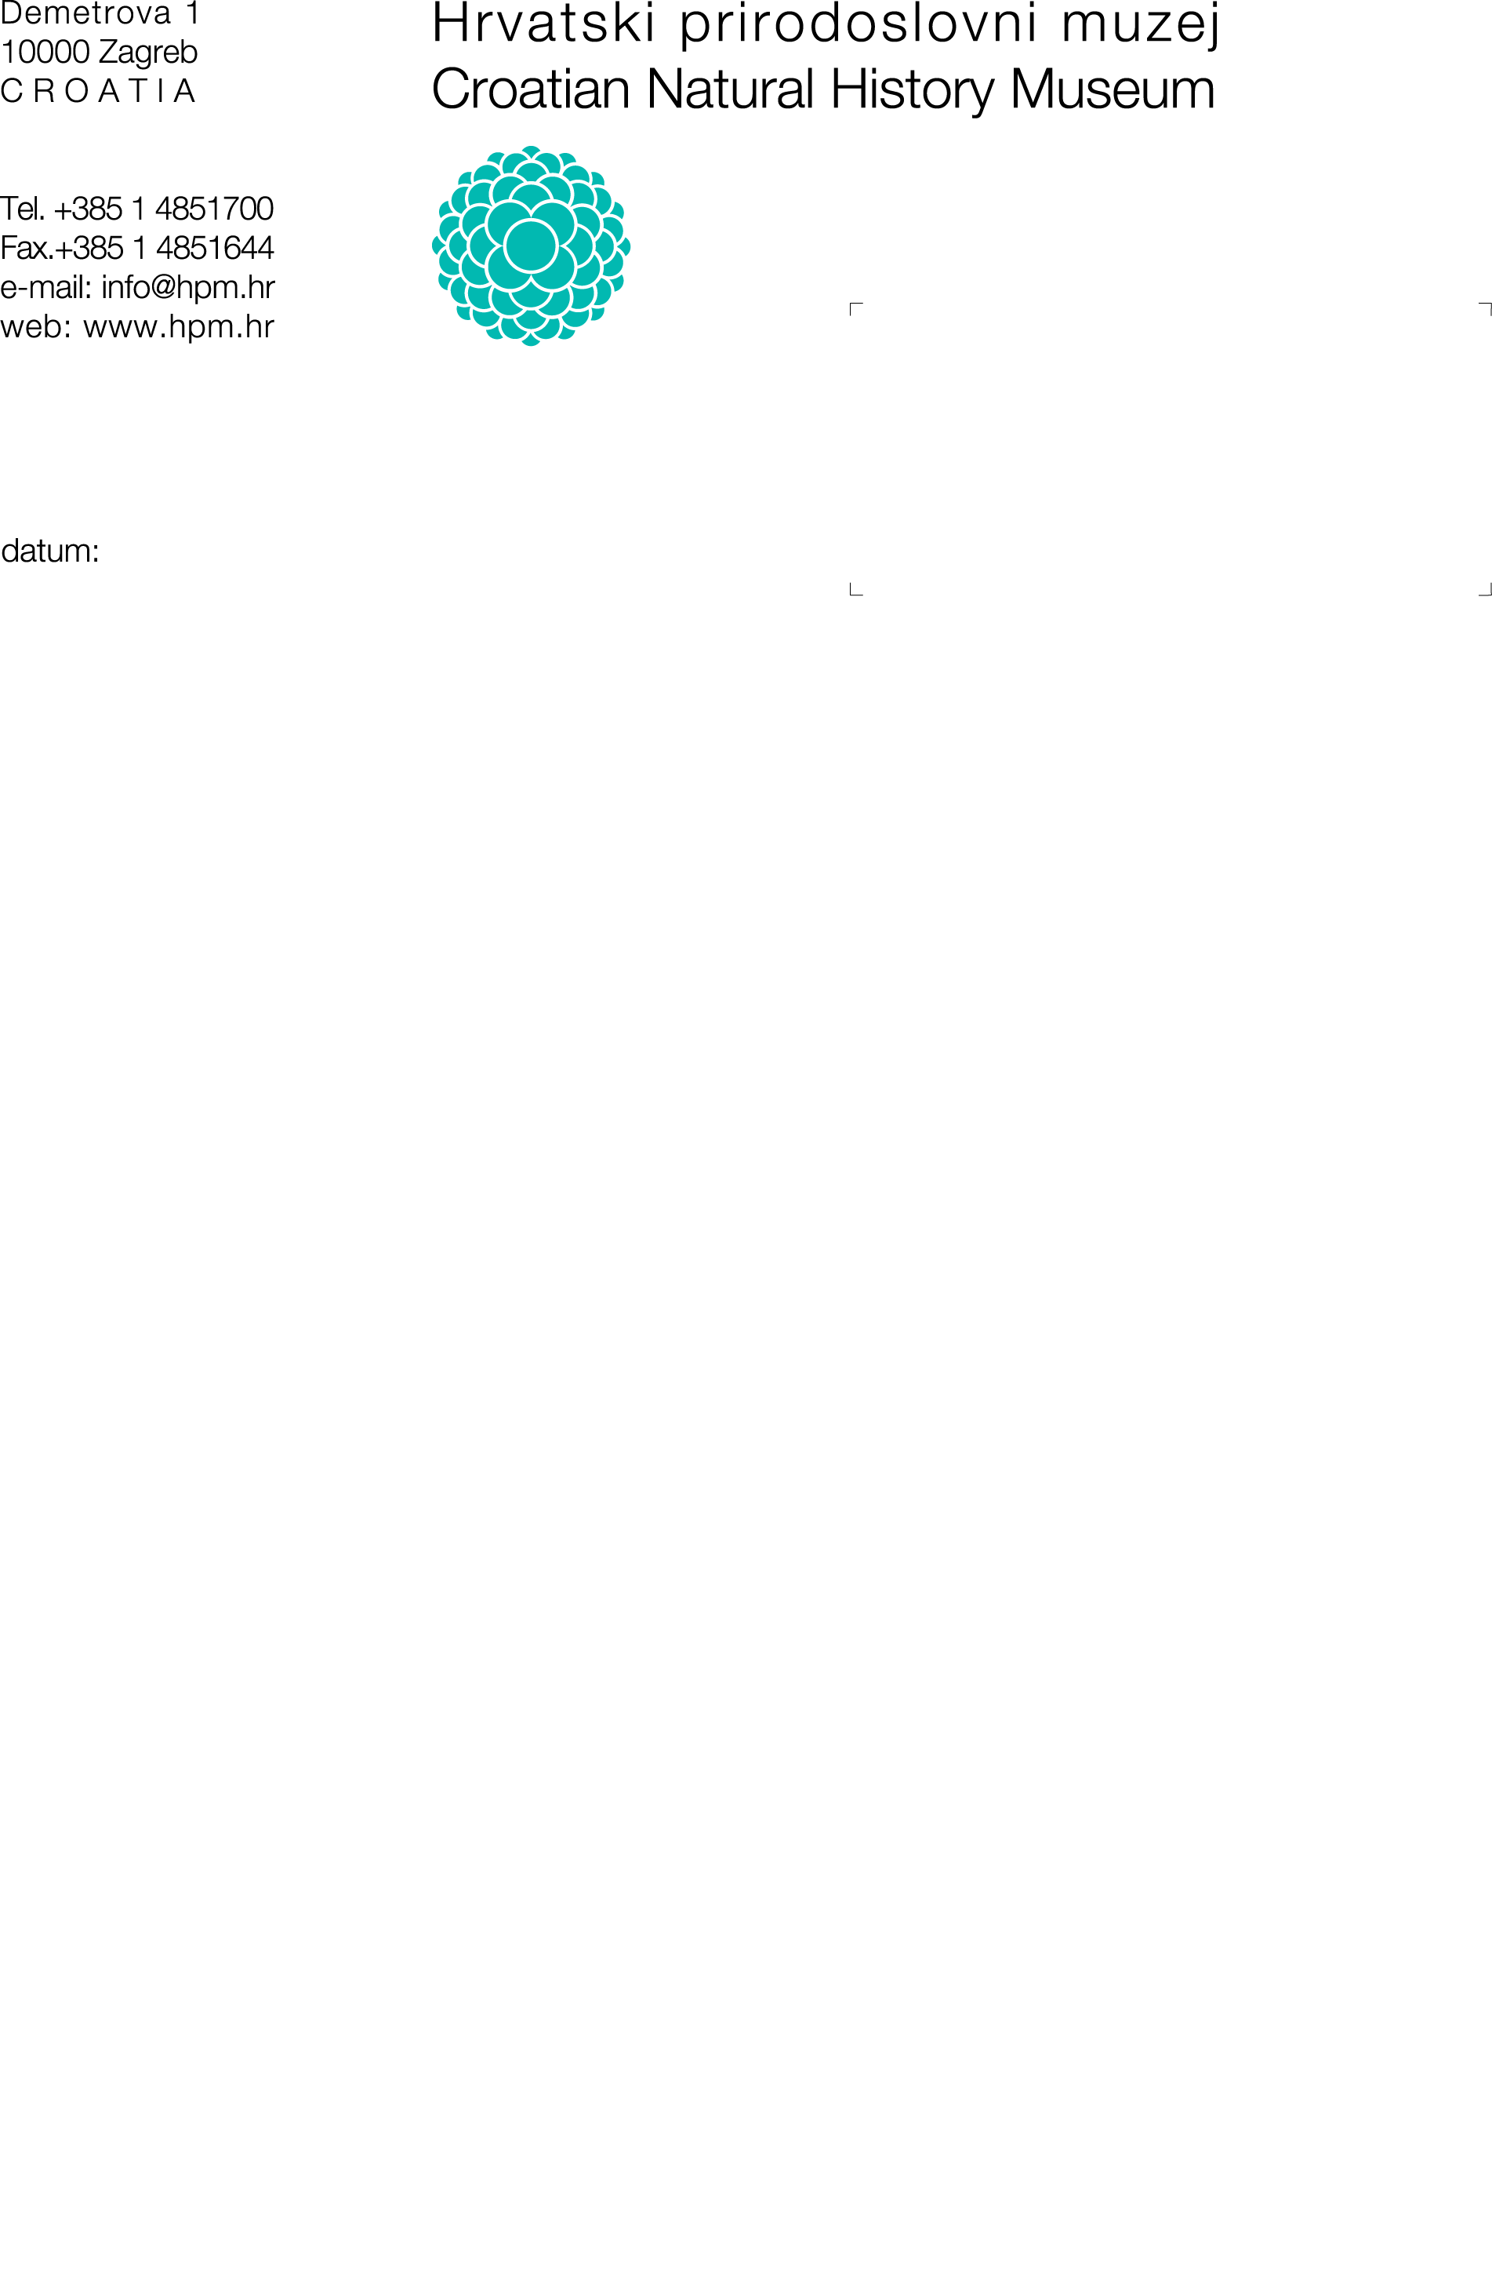or

1000 Zagreb

CLASS:
URNUMBER:
Date:
- REQUEST FOR THE PERMISSION
TO ACCESS MUSEUM COLLECTIONS AND DOCUMENTATION OF THE

CROATIAN NATURAL HISTORY MUSEUM
- Information about the applicant:
Name and surname:
Profession/ vocation:
ID number/ OIB:
Address:
Phone number:
Email:
Name of institution:
- Information on museum materials and/or museum documentation:
I ask to be granted an access into the following museum collections and documentation (specify and describe the museum material and/or documentation requested for inspection, and if known, indicate the name of the museum collection/documentation fund and the inventory number of items/acts/files,):

- Purpose of insight into museum collections and/or museum documentation
(scientific and professional processing, presentation, publication, publicist purposes, for teaching purposes, etc. and describe the topic or subject of research)
- Please make me the following (copy, recording, etc.) :
- PERMISSION
TO ACCESS MUSEUM COLLECTIONS AND DOCUMENTATION
The request for access to museum material and/or museum documentation is
GRANTED NOT GRANTED*
*Note: if the application is not approved, the applicant will receive a reasoned decision of the director about the reasons for the refusal.
Director:
_____________________________
prof.dr.sc. Tatjana Vlahović

- CONDITIONS AND MANNER OF GAINING ACCESS TO MUSEUM COLLECTIONS AND DOCUMENTATION
in accordance with the Ordinance on the content and manner of keeping documentation on museum collections and museum activities and the manner of obtaining permission to access museum collections and documentation ( Official Gazette RH No. 21/2023)
Museum collections and documentation are made available for the purpose of professional and scientific processing, exhibition, publication and for educational purposes or other justified purposes.
Insight into museum collections and documentation includes reviewing the collections and documentation and making recordings of the original.
Insight into the museum collections and documentation that has the purpose of its use for commercial purposes is mandatory regulated by a special contract between the Museum and the user, in accordance with the general acts of the museum and special regulations.
In order to gain insight into museum collections and documentation, an interested person submits a written request on the form located on the museum's website, in which the personal data of users are entered, the purpose of insight and the topic or subject of research.
Museums protect users' personal data in accordance with the law governing the protection of personal data.
As a rule, museum collections and documentation are given for inspection in digital form.
If there are no digital records, the museum is obliged to organize a recording of the originals at the request and expense of the user, and with the prior approval of the director. The cost estimate of insight-related services can be found on the Museum's website.
Original material and documentation may be made available only if the preservation of the material permits and if required by the professional and scientific method of work, provided that special protection measures are implemented.
Museum collections and documentation may be made available only at the museum premises under conditions that guarantee the safety and appropriate use of the entrusted material and documentation.
For any damage and incurred violation of the rights of third parties by using museum collections and documentation, a person or a legal entity who has been authorized to use collections and documentation is responsible, in accordance with the law.
For publication or any form of use of museum collections and documentation, the user is obliged to request in writing a special approval of the director.
The user is obliged to indicate the source and inventory mark of the object in publications using information on museum collections and documentation.
In the case of publication of data on museum collections and documentation, the user is obliged to provide bibliographic data on the publication or appropriate information on other forms of publication.
The Museum may, in accordance with its needs, ask the user to submit secondary documents (drawings, photographs, etc.) created by using museum collections and museum documentation in digital form.
Requests for must be submitted to the Museum's address: Demetrova 1, 10 000 Zagreb, or to e-mail: info@hpm.hr . Permission shall be granted no later than ten days from the date of submission of the application. The authorization is valid only for the person who submitted the application and signs that he is familiar with the manner and conditions of insight into the museum material and documentation.

IV. Signature of the applicant (user) : _______________________________________________

Date and place: __________________________________________

